What is a Pointer in C?
A pointer is defined as a derived data type that can store the address of other C variables or a memory location. We can access and manipulate the data stored in that memory location using pointers.
As the pointers store the memory addresses, their size is independent of the type of data they are pointing to. This size of pointers only depends on the system architecture.
Syntax:
The syntax of pointers is similar to the variable declaration in C, but we use the ( * ) dereferencing operator in the pointer declaration.
datatype * ptr;
where
- ptr is the name of the pointer.
- datatype is the type of data it is pointing to.
The above syntax is used to define a pointer to a variable. We can also define pointers to functions, structures, etc.
How to Use Pointers?
The use of pointers can be divided into three steps:
- Pointer Declaration
- Pointer Initialization
- Dereferencing
1. Pointer Declaration
In pointer declaration, we only declare the pointer but do not initialize it. To declare a pointer, we use the ( * ) dereference operator before its name.
Example
int *ptr;
The pointer declared here will point to some random memory address as it is not initialized. Such pointers are called wild pointers.

2. Pointer Initialization
Pointer initialization is the process where we assign some initial value to the pointer variable. We generally use the ( & ) addressof operator to get the memory address of a variable and then store it in the pointer variable.
Example:
int var = 10;
int * ptr;
ptr = &var;
We can also declare and initialize the pointer in a single step. This method is called pointer definition as the pointer is declared and initialized at the same time.
Example
int *ptr = &var;
Note: It is recommended that the pointers should always be initialized to some value before starting using it. Otherwise, it may lead to number of errors.
3. Dereferencing
Dereferencing a pointer is the process of accessing the value stored in the memory address specified in the pointer. We use the same ( * ) dereferencing operator that we used in the pointer declaration.
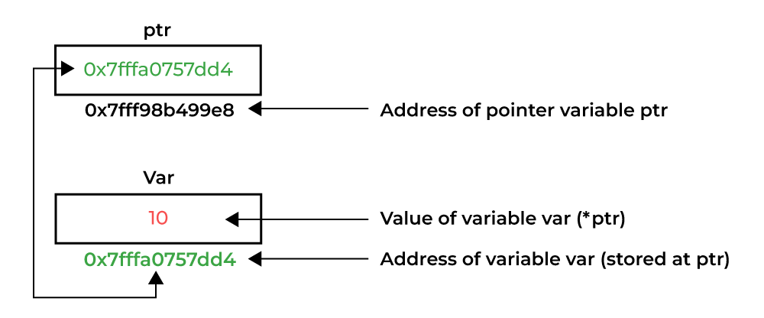

Pointer in C Example:
C program to illustrate Pointers
#include <stdio.h>
void geeks()
{
int var = 10;
// declare pointer variable
int* ptr;
// note that data type of ptr and var must be same
ptr = &var;
// assign the address of a variable to a pointer
printf("Value at ptr = %p \n", ptr);
printf("Value at var = %d \n", var);
printf("Value at *ptr = %d \n", *ptr);
}
// Driver program
int main()
{
geeks();
return 0;
}
Output
Value at ptr = 0x7fff1038675c
Value at var = 10
Value at *ptr = 10
Types of Pointers:
Pointers can be classified into many different types based on the parameter on which we are defining their types. If we consider the type of variable stored in the memory location pointed by the pointer, then the pointers can be classified into the following types:
1. Integer Pointers
As the name suggests, these are the pointers that point to the integer values.
Syntax
int *ptr;
These pointers are pronounced as Pointer to Integer.
Similarly, a pointer can point to any primitive data type. It can point also point to derived data types such as arrays and user-defined data types such as structures.
2. Array Pointer
Pointers and Array are closely related to each other. Even the array name is the pointer to its first element. They are also known as Pointer to Arrays. We can create a pointer to an array using the given syntax.
Syntax
char *ptr = &array_name;
3. Structure Pointer
The pointer pointing to the structure type is called Structure Pointer or Pointer to Structure. It can be declared in the same way as we declare the other primitive data types.
Syntax
struct struct_name *ptr;
In C, structure pointers are used in data structures such as linked lists, trees, etc.
4. Function Pointers
Function pointers point to the functions. They are different from the rest of the pointers in the sense that instead of pointing to the data, they point to the code. Let’s consider a function prototype – int func (int, char), the function pointer for this function will be

Syntax
int (*ptr)(int, char);
5. Double Pointers
In C language, we can define a pointer that stores the memory address of another pointer. Such pointers are called double-pointers or pointers-to-pointer. Instead of pointing to a data value, they point to another pointer.
Syntax
datatype ** pointer_name;
6. NULL Pointer
The Null Pointers are those pointers that do not point to any memory location. They can be created by assigning a NULL value to the pointer. A pointer of any type can be assigned the NULL value.
Syntax
data_type *pointer_name = NULL;
or
pointer_name = NULL
It is said to be good practice to assign NULL to the pointers currently not in use.
7. Void Pointer
The Void pointers in C are the pointers of type void. It means that they do not have any associated data type. They are also called generic pointers as they can point to any type and can be typecasted to any type.
Syntax
void * pointer_name;
One of the main properties of void pointers is that they cannot be dereferenced.
Size of Pointers in C:
The size of the pointers in C is equal for every pointer type. The size of the pointer does not depend on the type it is pointing to. It only depends on the operating system and CPU architecture. The size of pointers in C is
- 8 bytes for a 64-bit System
- 4 bytes for a 32-bit System
The reason for the same size is that the pointers store the memory addresses, no matter what type they are. As the space required to store the addresses of the different memory locations is the same, the memory required by one pointer type will be equal to the memory required by other pointer types.
How to find the size of pointers in C?
We can find the size of pointers using the sizeof operator as shown in the following program:
Pointer Arithmetic:
The Pointer Arithmetic refers to the legal or valid arithmetic operations that can be performed on a pointer. It is slightly different from the ones that we generally use for mathematical calculations as only a limited set of operations can be performed on pointers. These operations include:
- Increment in a Pointer
- Decrement in a Pointer
- Addition of integer to a pointer
- Subtraction of integer to a pointer
- Subtracting two pointers of the same type
- Comparison of pointers of the same type.
- Assignment of pointers of the same type.
C program to illustrate Pointer Arithmetic

#include <stdio.h>

int main()
{

// Declare an array
int v[3] = { 10, 100, 200 };

// Declare pointer variable
int* ptr;

// Assign the address of v[0] to ptr
ptr = v;

for (int i = 0; i < 3; i++) {

// print value at address which is stored in ptr
printf("Value of *ptr = %d\n", *ptr);

// print value of ptr
printf("Value of ptr = %p\n\n", ptr);

// Increment pointer ptr by 1
ptr++;
}
return 0;
}

Output
Value of *ptr = 10
Value of ptr = 0x7ffe8ba7ec50
Value of *ptr = 100
Value of ptr = 0x7ffe8ba7ec54
Value of *ptr = 200
Value of ptr = 0x7ffe8ba7ec58

C Pointers and Arrays:
In C programming language, pointers and arrays are closely related. An array name acts like a pointer constant. The value of this pointer constant is the address of the first element. For example, if we have an array named val then val and &val[0] can be used interchangeably.
If we assign this value to a non-constant pointer of the same type, then we can access the elements of the array using this pointer.
Example 1: Accessing Array Elements using Pointer with Array Subscript
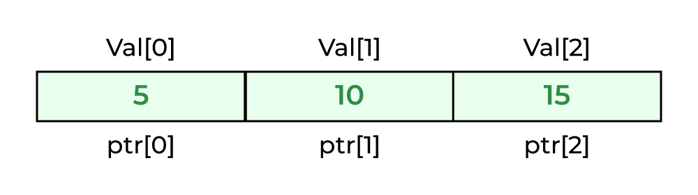
C Program to access array elements using pointer
#include <stdio.h>
void geeks()
{
// Declare an array
int val[3] = { 5, 10, 15 };
// Declare pointer variable
int* ptr;
// Assign address of val[0] to ptr.
// We can use ptr=&val[0];(both are same)
ptr = val;
printf("Elements of the array are: ");
printf("%d, %d, %d", ptr[0], ptr[1], ptr[2]);
return;
}
// Driver program
int main()
{
geeks();
return 0;
}
Output
Elements of the array are: 5 10 15

C Program to access array elements using pointers
#include <stdio.h>
int main()
{
// defining array
int arr[5] = { 1, 2, 3, 4, 5 };
// defining the pointer to array
int* ptr_arr = &arr;
// traversing array using pointer arithmetic
for (int i = 0; i < 5; i++) {
printf("%d ", *ptr_arr++);
}
return 0;
}
Output
1 2 3 4 5
Uses of Pointers:
The C pointer is a very powerful tool that is widely used in C programming to perform various useful operations. It is used to achieve the following functionalities in C:
- Pass Arguments by Reference
- Accessing Array Elements
- Return Multiple Values from Function
- Dynamic Memory Allocation
- Implementing Data Structures
- In System-Level Programming where memory addresses are useful.
- In locating the exact value at some memory location.
- To avoid compiler confusion for the same variable name.
- To use in Control Tables.
Advantages of Pointers:
Following are the major advantages of pointers in C:
- Pointers are used for dynamic memory allocation and deallocation.
- An Array or a structure can be accessed efficiently with pointers
- Pointers are useful for accessing memory locations.
- Pointers are used to form complex data structures such as linked lists, graphs, trees, etc.
- Pointers reduce the length of the program and its execution time as well.
Disadvantages of Pointers:
Pointers are vulnerable to errors and have following disadvantages:
- Memory corruption can occur if an incorrect value is provided to pointers.
- Pointers are a little bit complex to understand.
- Pointers are majorly responsible for memory leaks in C.

